

# ID:24045

# Names:Tunga Neville

FACULTY OF INFORMATION TECHNOLOGY

DEPARTMENT OF SOFTWARE ENGINEERING

Web Technology and Internet Final Project

# **Creative Craze Documentation**

**Introduction**

Welcome to the documentation for Creative Craze, a platform designed to assist artists in registering themselves and connecting with other artists (A sort of github for artists and their art). This documentation will guide you through the features, functionalities, and benefits of Creative Craze.

**Overview**

Creative Craze aims to create a seamless experience for artists, facilitating efficient communication and collaboration. By utilizing this platform, artists gain the opportunity to enhance their careers and gain valuable experience.

**Key Features**

1. **Artist Registration**
   * Artists can create an account on Creative Craze by providing their personal details, including contact information, Nationality, portfolio images, and a description of them and their work.
   * Secure authentication mechanisms ensure the privacy and confidentiality of artist profiles.
2. **Profile Management**
   * Artists can update their profiles with the latest information, including , portfolio updates, and pictures.
   * Artists can upload and manage their portfolio images and documents, showcasing their work to other artists and potential clients.

**Benefits**

1. **Enhanced Visibility**
   * Artists gain exposure to a wide range of agencies and potential clients, increasing their chances of securing more opportunities and collaborations.
   * Agencies can discover talented artists, expanding their talent pool and reaching a larger audience.
2. **Targeted Talent Search**
   * Agencies can leverage advanced search filters to find artists that precisely match their requirements, ensuring optimal talent selection.
3. **Professional Growth**
   * Artists can gain valuable experience by discovering with a variety of other artists and clients, helping them build their portfolios and advance their careers

**Conclusion**

Creative Craze provides a comprehensive platform for artists to register themselves and connect themselves, empowering both parties to thrive in the art industry. By leveraging the features and benefits of Creative Craze, artists can expand their reach and gain valuable experience, while gallerias can efficiently manage their talent and foster professional growth.

**User Documentation**

**Key Features**

1. **Authentication and Authorization**
   * Creative Craze implements Spring Security for authentication and authorization purposes.
   * Artists and admins have separate roles and access levels, ensuring data privacy and security.
   * Access to specific endpoints and data is restricted based on user roles.
   * If a user tries to access a restricted URL, they will be redirected to an appropriate error page.
2. **Artist CRUD Operations**
   * Artists can perform CRUD (Create, Read, Update, Delete) operations on their own profiles.
   * They can create their profiles, view and update their information, and delete their accounts if needed.
   * Artist-specific data is isolated from the admin data.
   * Artist can delete and update his data.
   * But Admin Can view the data of all the artists but not edit it he/she can reject only and that will send a notification email informing and artist of their rejection.
3. **Admin CRUD Operations**
   * Admins have the ability to perform display on admin-specific data and user accounts.
   * Admin-specific data is isolated from the artist data and they can reject any artist profile and portfolio while artists can only delete and update their own profiles.
4. **File Upload and Download**
   * Creative Craze supports file upload and download functionalities.
   * Artists can upload portfolio images in various formats (JPEG, PNG, etc.) to showcase their work.
   * Users can download files, such as their portfolio they created.

**Technical Documentation**

**Technologies Used**

1. **Spring Boot**
   * Spring Boot framework is used as the foundation for developing the Creative Craze app.
   * It provides a streamlined development experience, including automatic configuration and dependency management.
2. **Java**
   * The Creative Craze app is implemented using Java as the primary programming language.
   * Java enables the backend functionality and supports the integration of various libraries and frameworks.

**Packages and Project Structure**

1. **Appsecurity**
   * This package contains classes related to authentication and authorization.
   * Spring Security is used for implementing secure authentication and role-based access control.
2. **Config**
   * The config package includes configuration classes for the application.
   * It contains settings for data sources, security, and other necessary configurations.
3. **Controller**
   * The controller package houses the controllers responsible for handling incoming HTTP requests and generating appropriate responses.
   * Controllers receive requests from the frontend and communicate with the appropriate services.
4. **Dto**
   * The dto (Data Transfer Object) package contains classes that define the data structures used for communication between the frontend and backend.
   * These classes typically represent request and response payloads.
5. **Model**
   * The model package holds the domain artist classes representing entities in the application.
   * These classes are typically mapped to database tables and contain the business logic.
6. **Repository**
   * The repository package includes interfaces or classes responsible for database operations.
   * It provides methods to perform CRUD operations and query the database using frameworks such as Spring Data JPA.
7. **Services**
   * The services package contains classes that implement the application's business logic.
   * These classes interact with the repositories, perform operations on the data, and handle the app's functionality.

**Frontend Resources**

1. **Webpages**
   * The frontend of the Creative Craze app consists of webpages that are responsible for user interactions and rendering.
   * The webpages are created using HTML, CSS, and JavaScript.

**ARCHITECTURE OF THE DATABASE**

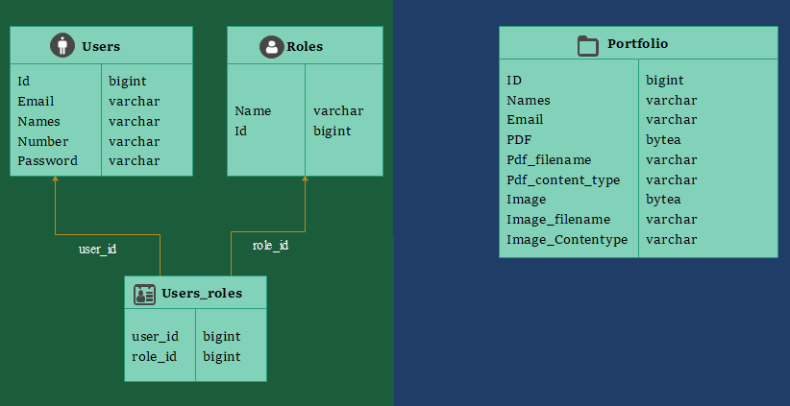

**IN SUMMARY**

Creative Craze is a Spring Boot application built using Java. It provides a platform for artists to register themselves and connect themselves. The app incorporates authentication and authorization using Spring Security to ensure data privacy and security. The backend functionality is organized into several packages, including appsecurity, config, controller, dto, artist, repository, and services. These packages handle authentication, configuration, request handling, data transfer objects, entity art, database operations, and business logic. Additionally, the app supports file upload and download functionalities for artists and admins, allowing them to manage portfolio images and relevant documents. The frontend of the app consists of webpages created using HTML, CSS, and JavaScript, facilitating user interactions and rendering. Overall, Creative Craze aims to streamline communication, enhance visibility, and provide professional growth opportunities for artists while empowering them and connecting them to form a community for themselves and their art.

**!!!!!!!APP AND ITS CREDENTIALS.**

**App:[Creative-Craze](https://creative-craze.onrender.com)**

**ADMIN**: [admincc@gmail.com](mailto:izereelliela@gmail.com)

**Password**:ccadmin123

**Artist(user)**: tylinux@mailsac.com

**Password**:auca@2020

Also you can Sign Up as another user and login. And continue on the dashboard to create portfolio

But for the Admin the credentials remain the same.